**ASSIGNMENT-2**

Q. 1. Check if all letters in a string are uppercase

Q. 2. Write a version of a palindrome recognizer that also accepts phrase palindromes such as : Was it a rat I saw? or Dammit, I'm mad!Note that punctuation, capitalization, and spacing are usually ignored.

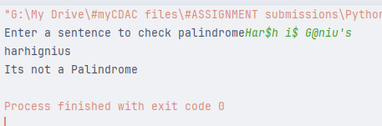

Q.3. Write a Python function that takes a list of words and returns the length of the longest one

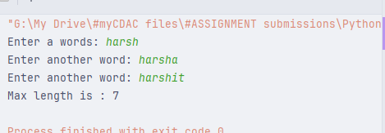

Q.4. Write a Python program to remove duplicates from a list

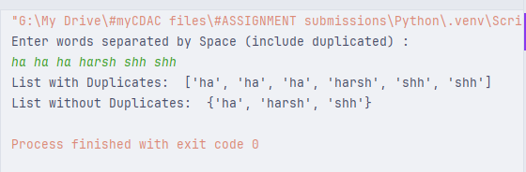

Q.5. Write a Python program to compute element-wise sum of given tuples, using “zip()” function

Original tuples:

(1, 2, 3, 4)

(3, 5, 2, 1)

(2, 2, 3, 1)

Element-wise sum of the said tuples:

(6, 9, 8, 6)

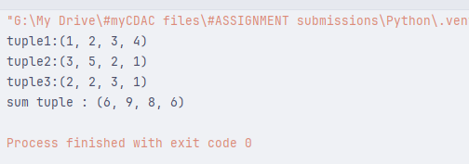

Q.6 In cryptography, a Caesar cipher is a very simple encryption techniques in which each letter in the plain text is replaced by a letter some fixed number of positions down the alphabet. For example, with a shift of 3, A would be replaced by D, B would become E, and so on. Create a cipher to represent each key with corresponding value as :

{'a': 'd', 'b': 'e', 'c': 'f', 'd': 'g', 'e': 'h', 'f': 'i', 'g': 'j', 'h': 'k', 'i': 'l', 'j': 'm', 'k': 'n', 'l': 'o', 'm': 'p', 'n': 'q', 'o': 'r', 'p': 's', 'q': 't', 'r': 'u', 's': 'v', 't': 'w', 'u': 'x', 'v': 'y', 'w': 'z', 'x': 'a', 'y': 'b', 'z': 'c'}

encrypted = sbwkrq

Expected output : decrypted = python

Q.7 For a given dictionary [Add few more entries]

employees = {'Amol' : ['C', 'C++','Java'],.....}

1. print employees and their skill sets

2. Find all the employees who know Java

3. Update skill for an employee

4. Add/remove employee data

